MSc Computer Science – Information
Security Lab Assignment 5
Harshit kumar more
Roll no: 16
Task 1: Encryption and Decryption (Additive Cipher)
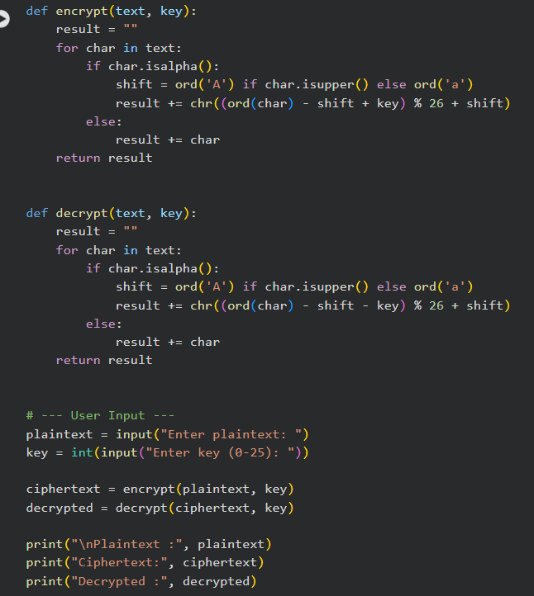
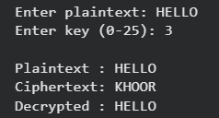

Task 2: Brute Force Cryptanalysis
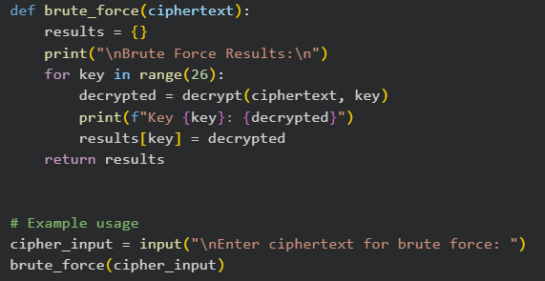
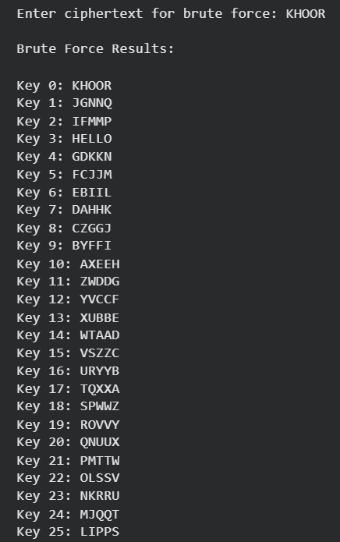

Task 3: Frequency Analysis Cryptanalysis
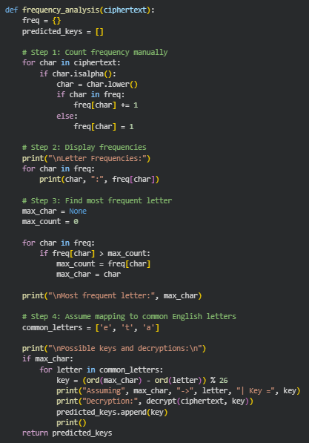
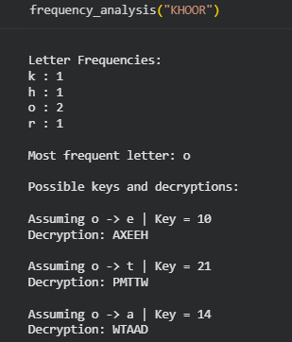

Task 4: Comparative Analysis
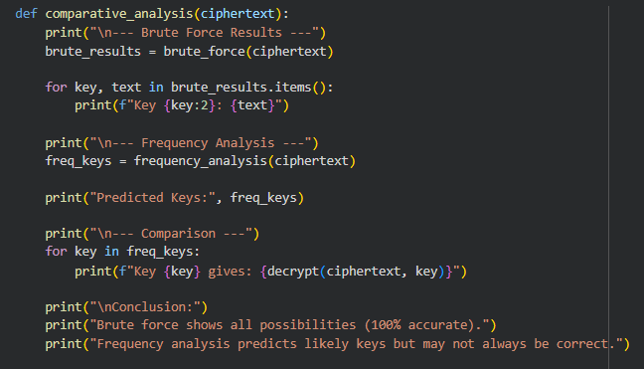
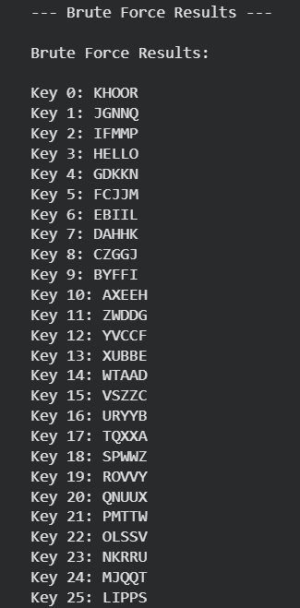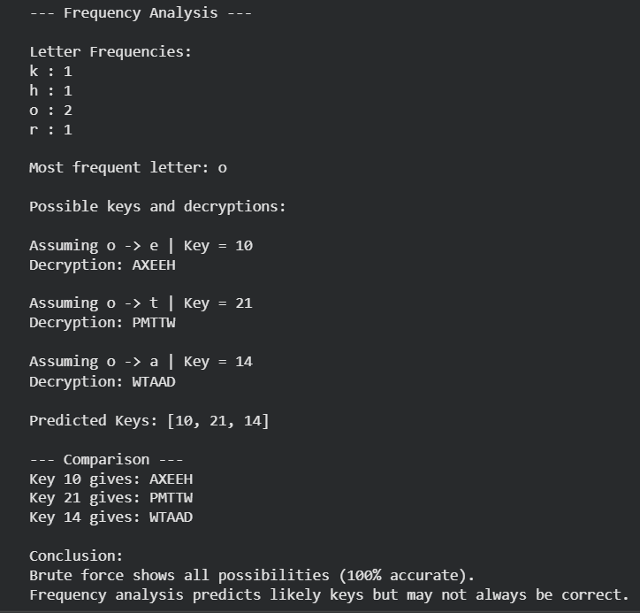

Brief Analysis :
Brute Force Decryption:
- Methodology: Systematically tests every possible key (0-25) and presents all 26 potential decryptions.
- Accuracy: 100% accurate in finding all possible plaintexts for a given ciphertext, including the correct one, provided the original text is recognizable.
- Drawbacks: Can be computationally intensive for more complex ciphers or larger key spaces. For Caesar cipher, it's efficient.
Frequency Analysis Decryption:
- Methodology: Analyzes the frequency of letters in the ciphertext and compares them to known letter frequencies in a given language (e.g., English). It then predicts keys based on the most frequent ciphertext letter mapping to common plaintext letters.
- Accuracy: Provides educated guesses for likely keys. Its accuracy depends on the length of the ciphertext (longer texts yield more reliable frequency patterns) and the consistency of the language's frequency distribution. It is not always accurate, especially with short or unusual texts.
- Drawbacks: May not identify the correct key if the ciphertext is too short or if the plaintext's letter frequencies deviate significantly from the typical distribution. In our example, it did not identify the correct key.
Conclusion: Brute force is a definitive method for Caesar cipher due to its small key space. Frequency analysis is a heuristic approach that can narrow down possibilities, but requires human interpretation or further confirmation, especially for short ciphertexts where statistical patterns are less pronounced.

